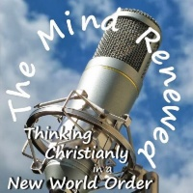

**The Mind Renewed #173**

**Julian Charles talks to Robert J. Marks II about Evolutionary Informatics**

**Julian Charles:** Hello everybody, Julian Charles here of themindrenewed.com coming to you from the depths of the Lancashire countryside here in the UK. Today is the 18th of May 2017, and I am very pleased to welcome to the programme Dr. Robert J. Marks II, who is Distinguished Professor of Engineering at Baylor University. Dr. Marks’s eponymous honours include – and I wonder if I can pronounce these correctly, but I’ll have a go – the Zhao-Atlas-Marks (ZAM) time-frequency distribution in the field of signal processing, the Cheung-Marks theorem in Shannon sampling theory and the Papoulis-Marks-Cheung (PMC) approach in multidimensional sampling. I’m sure Dr. Marks will correct me if I have any of those wrong in a minute. He was instrumental in defining the field of computational intelligence, and with his colleagues developed the temporal convolutional neural network, widely used in deep learning. In 2008 Dr. Marks appeared in the documentary movie *Expelled – No Intelligence Allowed* starring Ben Stein, and in 2013 he was listed among “The 50 Most Influential Scientists in the World Today” by TheBestSchools.org.[1] A Christian since 1970, Dr. Marks served for 17 years as the faculty advisor to Campus Crusade for Christ at the University of Washington. He is also married with three children, three grandchildren, two dogs, and, very importantly, a “stupid horse”. Dr Marks, thank you very much for joining us on the programme.

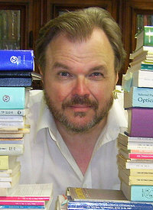**Robert Marks:** Ah, thank you; it’s a great honour to be a part of your series of broadcasts.

**JC:** That’s very good of you to say so. Thank you very much indeed, and I’m glad you told me about the “stupid horse”, but I should think that most people are thinking to themselves: “Well, I’m not sure I want to listen to the rest of the interview until I know about the “stupid horse””. So, could you tell us?

**RM:** Yeah, the “stupid horse”. You know every little girl wants a pony, and so as my wife matured and we could afford one, she got her dream and bought a horse, which just stands out in the field and eats my hay all day, and sometimes I feel like a “horse butler”. I have to go and attend to all the needs of the horse and say: “Thank you very much; yes I’m glad to clean your stall. Anything else that you need?” So, I have a very low opinion of the horse, but my wife loves it and I love my wife, so it stays.

**JC:** Wonderful. Well, I wish you’d told me that before, that you’re a “horse butler”, because I would have loved to have introduced you that way; that would have been absolutely wonderful.

**RM:** Yes, I have to put that in my resume, actually.

**JC:** Please do. Well of course we’re going to be discussing today your new book, which I believe is published this month. Is that right?

**RM:** Yes, yes, it came outin the early part of May.

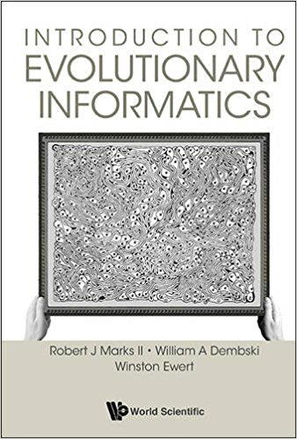**JC:** Great, and it’s called *Introduction to Evolutionary Informatics*, which you co-authored with the mathematician and philosopherWilliam Dembski and the research scientist and software engineer Winston Ewert. Now, I think the term *Evolutionary Informatics* will probably be a bit of a mystery to many listeners. Of course, I’ve had the benefit of reading your book in advance, but for the sake of those who haven’t come across terminology like that before, perhaps you could give us a brief description of what this book is about, and what you’ve sought to establish through it, essentially?

**RM:** Well, let's see. I think that the main premise in so far as evolution is that there exists no hard science model of Neo-Darwinian evolution, and I don’t think there’ll ever be, but I think in science you never say “never”, because you never know what’s going to come down the tracks. But I can say definitively that there currently exists no such model. And the way this is established is through first defining what you mean by information theory, and, second, looking at the attempts by the Neo-Darwinists – let’s call them – to establish evolution via models and via computer programmes, and why those are a failure in terms of undirected Neo-Darwinian search.

**JC:** And you also have a section in the book on Artificial Intelligence (AI) saying something along the lines of however powerful that may become, it will never rise to the heights of human creativity. Is that right?

**RM:** Yes, that’s exactly right. The human mind is above and beyond a computer, and much of the hype that goes on today about computers gaining consciousness like in *The Terminator* when Skynet gained consciousness and began to kill everybody, that isn’t applicable. And, how do you determine that? When you’re thinking about things, you always have to back to the fundamentals, and so if one goes back to the fundamentals of computers and computer science, I think that many of these conclusions about the limitation of the computer just fall out very naturally.

**JC:** Though Terminator 2 is an excellent film, you must admit, even though it is pure science fiction from your point of view.

**RM:** Oh, absolutely. I love Arnold (Schwarzenegger).

**JC:** How he ever came to be an actor, I’ve no idea, but he did a good job.

**RM:** I’ve no idea, but many times I excuse myself from meetings, and I walk to the door and turn around and say: “I’ll be *baack*!” So, I quote *The Terminator* quite often.

**JC:** Wonderful. Ok, so that’s what we’re going to be discussing, but I would first of all like to get a little more of an idea about your background Dr. Marks. Could you tell us a bit more about your work, and perhaps, most importantly for this podcast anyway, the relationship between the science you do and the Christian faith that you hold.

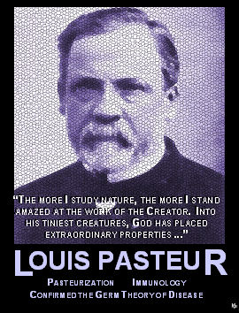 **RM:** Well, yes, I came to Christ when I was a junior in college, and it was a life-changing experience for me, and one that I’ve always been thankful to Our Lord that that possibility exists. I have never had a problem with the intersection of science and faith. In fact, I think that having the intersection of science and faith allows one to explore a broader realm of solutions than if one just adheres to total materialism or naturalism. So, therefore, the arena of solutions that one has is much broader, and I believe that in searching for the truth that there are things that exist outside of modelling, that exist outside of our understanding. That’s a topic for why the human mind will never become a computer, because there are things that we can prove that are not computable. In fact, we can prove things that are unknowable; we can prove they exist, we can also prove that they are unknowable – just astonishing.

But, I’m not the only one; if one looks at the history, at all the great scientists, mostly from Western Europe, that founded science as we know it today, many of them were Christians. I think of Louis Pasteur, who says “The more I study nature, the more I stand amazed at the work of the Creator and to his tiniest creatures God has placed extraordinary properties” and so people like Pasteur and others recognise the creation of God around them, and have celebrated it. I’m kind of a nerd, and I see God in things that other people don’t see. My wife will look at a beautiful meadow of flowers and she’ll say: “Oh, that’s so beautiful; I see God.” I look out and I see a meadow full of flowers. But, if you give me some good science or some mind-bending mathematics, my response is immediately: “I see God in this.” One day I hope to write a book on mathematical apologetics; I know it will not be a best seller, but for all the nerds in the world that see God in this creation, I think it might be a big hit.

**JC:** That’s very interesting, because that connects with some of the things that James Sire was saying on this show where he was saying, you know, some of things we see in reality, a kind of creative divine art work that’s presented to us, and we can just ‘get’ the presence of the Creator through that, so, in a sense, what you’re saying there seems to reflect that kind of approach to apologetics, an immediate experience.

**RM:** Yes, and I believe everybody has different coloured glasses. Different people see God in his creation in different aspects. My wife likes the meadow of flowers; I like the math and science.

**JC:** I think I’m probably with your wife on that one; I can’t imagine seeing a page of mathematics and seeing God in that, but anyway as you say it’s a very personal thing. So now, what a lot of people I think would say, having heard you there – I mean the very fact that you talked about your faith opening up lots of possibilities for solutions that perhaps materialists wouldn’t see – is that your faith is influencing your science, but a lot of people would say that therefore that’s a bad thing, you’re not doing pure science, you’re doing faith plus science.

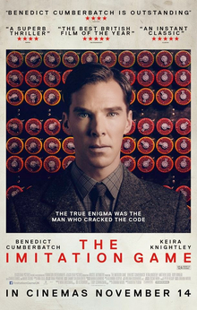

**RM:** Well, let me tell you that one’s ideology, if one is searching for truth, will ultimately not be a factor. Let me give you an example: Alan Turing, who you’re familiar with, I’m sure, is a British scientist who [helped break the code for the Nazi’s] Enigma [machine]. Although they made a movie about him, *The Imitation Game*, was not the main thing he did. He started computer science. Now, it was well known, of course, that Alan Turing was gay and that led, because of his unfortunate persecution, to his suicide, but the man was a genius because he founded computer science prior to computers existing. He did it on paper and all the computers we have today can be traced as generalisations, not even generalisations but special cases of the Turing machine. In other words, you can do stuff on the big computers we have today that you can also do [the same operations] on Turing’s original machine, so we haven’t got better, we’ve simply got faster, if you will. But, what was Turing’s motivation for doing this? When he was in high school he had a friend die of bovine tuberculosis, and this led him to doubt in God, and so therefore one of his motivations for finding computer science was to show that we were machines, and, ultimately, even though he held this ideology, Turing’s work has led to the conclusions that we talk about at the end of the book that the mind is greater than the computer. So, even though he had a specific ideology, his pursuance of truth led to a result contrary to his initial purpose, and I believe that that’s also the case with Intelligent Design sort of work. Eventually the truth is going to win out. The ideology that drives the research, if you will, doesn’t matter.

**JC:** Yes, that makes a lot of sense, and, of course, looking back at history, you were saying about famous scientists from the past who have been Christians, you would have to write off all their work, wouldn’t you, as a consequence of that kind of criticism, so I agree with you. Yes, it doesn’t really matter what your motivation is so long as you are geared towards finding truth as the answer.

**RM:** And I think that in debate that’s referred to as something like the Genetic Fallacy, which is that one doesn’t deal with what is proposed, but one points to the person and says: “Well, that can’t be right, because you’re stupid.”

**JC:** Now, you mentioned Intelligent Design there; that’s often conflated in the media with Creationism, by which I think they usually mean theories guided by scriptural interpretation – primarily guided by scripture. How would you distinguish Intelligent Design from that kind of Creationism?

**RM:** Well, Creationism, as I understand it, looks at Genesis and attempts to make sure that all history and science conforms to Genesis. Those involved in Intelligent Design, on the other hand, believe that… as we pursue truth, we are going to find things that are consistent with the Christian faith, and if they’re not consistent with the Christian faith, then, well, maybe we have a problem there. That, I think, is the big difference. We are actually looking at truth believing that if our faith is true that anything we discover is going to be consistent with that faith.

**JC:** Now, Stephen Meyer says that Intelligent Design does not commit to the God of the gaps fallacy, where you have a gap, in theory, and you say: “Oh!, we don’t understand that; therefore that must be caused by God.” But he says that Intelligent Design really argues from what we do know about design in ordinary life. Do you agree with his arguing from what we do know rather than being a God of the gaps fallacy?

**RM:** Yes, I believe that the complexity that we observe around us in daily experience cannot be explained by a blind search, a blind Darwinian sort of process, so, yes, absolutely.

**JC:** Ok, so we’re going to be looking at these evolutionary models that are out there in a little while, but before we start that I want to ask you a basic kind of question in your approach to this. Am I right in thinking you’re not saying that evolution does not happen and has not happened, but rather you are critiquing the models that are out there, and saying that they are essentially not up to the job?

**RM:** Exactly, I’m looking at the models that have been proposed by the Neo-Darwinists, and we’ve analysing those and showing that they won’t hold water.

**JC:** Ok, good. So we’ll turn to the book then, and the first thing that I want to say about this is that I enjoyed the book very much. I think it’s an extremely interesting book, but I have to say I don’t think it’s easy, and I can see that you’ve aimed it at the non-specialist, of course, but I think it’s true to say that it still does require a fairly high level of mathematical literacy, at least by high school standards, anyway, to get the most from it. On the other hand, you do provide many descriptions and illustrations to help people like me, who have rather distant memories of our high school maths, to get the gist of what’s being said, so I certainly think it is a very rewarding book, but not always easy. Do you think that you have got the balance right?

**RM:** That’s always a good question. I think Einstein said: “Explain things as simple as possible, but not simpler.” We’ve attempted to do that in the book, but can it be made simpler and more accessible? Yes, I think it can, but that’s going to take some head scratching and some thinking of ways to do things.

**JC:** Yeah, I wouldn’t envy you the task. I just wondered if you could have done what Michael Behe did with his book *Darwin’s Black Box*, and actually box off some of the more technical sections, though I know in a sense you did do that in the text. You said people could skip the next couple of pages, but he actually did box them off. I wonder whether that would have been a way to go with that?

**RM:** Well, we didn’t box them off, but we did put little daggers by all the places that could be skipped that are kind of nerdy and mathematical, so there are entire sections and foot notes with little daggers by them that said: “You can skip this.” I think we actually maybe mentioned that we were motivated by Behe’s book.

**JC:** I think it might have been that I had an earlier copy, so maybe you added that later, did you?

**RM:** Yes, that could have been.

**JC:**  Ah, that explains everything.

**RM:** But currently in the in-print version everything is daggered off, and I did this because when I read Behe’s *Black Box* – I’m not a bio-chemist, I’m an engineer – I wasn’t following some of the technical details, and him doing that really helped me to understand the book without getting into the nitty gritty details, so we were motivated by that in his book to do exactly the same thing in this book.

**JC:** Excellent. So, as I say, I’ve got a pre-publication copy without that, so that explains it. Ok, so I want to ask you about the legitimacy of your project itself here, because you are applying principles of information theory, which we’ll get into in a minute – very mathematical stuff – to these current models of evolution to see if those models stand up, but some people, I’m sure, would say that’s basically not legitimate, that you can’t model biological evolution on computers, it’s too complex to be modelled. What do you say to that?

**RM:** Well, I say if somebody says that evolution is too complex to be modelled then they would be agreeing with the premise there exists no hard science model of Neo-Darwinian evolution. So, they’re actually agreeing with me. I think that the underlying reason is a little bit different, but they’re agreeing that there exists no model, and therefore the Darwinian sort of evolution itself is not a hard science.

**JC:** So, you’re saying that in order to be a hard science, it must be capable of mathematical modelling.

**RM:** Yes, and many things in biology are modelled that way. I have a colleague here, Keith Schubert, who’s doing extreme life. He goes down into sulphur caves and looks at life in these extreme conditions and he’s using finite automata theory in order to model that. In history there’s the Lotka-Volterra Predator Prey Equations, there’s mathematical epidemiology, and all sorts of modelling in biology. Every hard science has a model which is mathematical. Outside of biology, you have something called Maxwell’s Equation in electromagnetics, [classical] mechanics is modelled by Newtonian Laws, quantum theory by Schrödinger’s Equation, etc. etc. So, all the hard sciences have mathematics as their foundation, and even soft sciences, like finance, use sophisticated models that win Nobel prizes. One of the greatest and most creative mathematicians of my generation, Gregory Chaitin (who, by the ways gave a review of our book, which is kind of cool) said the honour of mathematics requires us to come up with a mathematical theory of evolution and either prove that Darwin was wrong or right, and that’s something that I agree with. In this book we have shown that the Neo-Darwinian model does not exist; I don’t think it will ever exist.

**JC:** Well, as much as I can understand of the book, you do seem to make a very compelling case, I have to say that. I can imagine, however, somebody coming back to you and saying: “But, you’re not a biologist, you’re an engineer, so how can you be well-placed to look at this problem?”

**RM:** That’s exactly right, I’m not a biologist, I am an engineer, but engineers again are different than scientists because scientists celebrate their models and place them up on thrones like a queen and worship them. Engineers, on the other hand, make the queen come down and scrub the floor and if she doesn’t work, we fire her. So, that is a big difference. Evolution has been a part of engineering ****ever since the advent of the computer. In fact in the 60s and 70s people were saying we can’t wait to get fast computers because we aren’t able to show in the laboratory the process of Darwinian evolution because it is so darned slow, and so they said let’s get some computer programmes able to show that Darwinian evolution works. Now, engineers have taken evolution and have actually applied it to some very interesting things. NASA scientists, for example, used evolutionary computation – there’s actually a whole field in engineering called evolutionary computation – and they have designed an antenna, which is flying around in space right now. They evolved this using a computer programme. My first paper that had to do with evolution was, I believe, over twenty-two years ago, and I was administratively part of founding the premier evolutionary computing journal, the *IEEE Transactions on Evolutionary Theory*, so, yes, I’m not a biologist, but I do know the modelling and I do know the theory of evolution, and that’s what we’ve been applying here.

**JC:** Ok, and you brought up that business about the NASA antenna that had been produced, did you say, by an evolutionary programme which would suggest, just looking at the surface of this, that well, yes, evolutionary algorithms do in fact work, so it proves Neo-Darwinism, but, of course, you are critiquing those very processes themselves and finding that they need to have informational input beyond what we normally think of as evolutionary processes – we’ll comeback to that NASA example in a few minutes. Now, if we’re going to use, as you do, information theory to assess these models of biological evolution, I think we need to have some basic idea of what Information Theory is. So, could you give us a basic kind of definition of what that is?

**RM:** That’s an excellent question, because any time one talks about evolution or information, one needs to get definitions before one proceeds. That’s the reason I’ve tried to be careful of defining what I mean by undirected Neo-Darwinian evolution as the type of evolution that we’re critiquing. Information is a term which is thrown around a lot, but nobody sits down to define it, and if you think about it, you have to answer questions of the following type: if I take a DVD and I shred it, am I destroying information? If I take a book and I burn it, am I destroying information? When I take a picture with my camera and all that information is stored, we know that there’s a certain amount of bytes, am I creating information? Then again, if I erase that file, have I destroyed information? So, the answer to that question is this: it depends on your definition of information, and as a nerd I like to see it precisely defined so that we can talk about it without ambiguity. In the world of information there are two major theories: one is Shannon Information. Shannon founded Information Theory in one great paper in 1948, and we’re still using his technology today. Your cell phones use technology that was derived from Shannon’s 1948 paper. He was a guy that worked for Bell Labs – just an incredible genius. The other one is the so-called Kolmogorov Information Theory, which is a different type of information. It is sometimes referred to as Kolmogorov-Chaitin-Solomonov Information Theory because there were three guys that discovered it independently of each other. In fact, the middle name, Chaitin, is the one that said: “Hey, in evolution we must come up with a model and prove Darwin’s right or wrong”. Chaitin is a true genius and maybe one of the most creative mathematicians, at least of my generation.

[Kolmogorov Information Theory] has to do with actual structure, and it’s the Kolmogorov Information that is a part of our world, and is as much a part of creation as is matter and energy and time. So again we need to define exactly what we mean by that information.

**JC:** Can I just ask you here . . .

**RM:** Sure.

**JC:** . . . just coming at it from a very intuitive approach, you know, you’re asking about do you destroy information that’s on a book when you burn it. I was just thinking if you were to read that book into a dictation machine, and then you were to destroy the book, would you then have destroyed the information? The information would have been transferred.

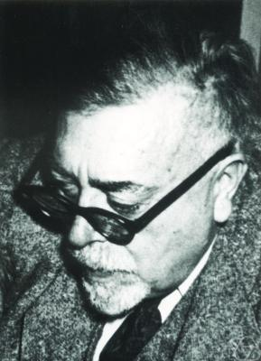**RM:** Exactly, exactly.

**JC:** It’s not a material thing, is it?

**RM:** Oh, this is the fascinating part: Norbert Wiener – great name for a guy – was the father of cybernetics and he said information is information neither matter nor energy. In other words, you can take information and you can write it on energy, that’s what we use in our wireless communications, right? We have all this information flowing around in the airwaves on electro-magnetic fields. It can also be etched onto matter; that’s what a CD, or a DVD or a book is: information that has been etched on matter. But, the matter itself and the energy itself is not information; information lies separate from that.

**JC**: It could even be knotted onto string, couldn’t it? Wasn’t it the ancient South Americans who used to have a way of writing just by tying knots in string?

**RM:** I’m not familiar with that, but certainly that would be very close to the ones and zeros that we use, wouldn’t it?

**JC:** Indeed. So, you’ve got this Shannon information, and – I’m going to abbreviate this – the KCS Information; those are two different measures of information, is that right?

**RM:** Yes, yes.

**JC:** And the first one, the Shannon one, has to do with probability, measuring it in terms of probability, and the other one, the KCS, has something to do with making the smallest computer programme that could describe the information. Is that the basic difference between the two?

**RM:** Yes. KCS Information - you’re familiar with 3D Printers of course? Suppose we were to write a programme and wanted to do the bust of – I’d better use somebody British - say Churchill, for example, and were to create a 3-dimensional bust of Churchill for which we wrote a programme. We wanted to include everything. One of the most famous pictures of Churchill, I understand, was one of him scowling that the photographer achieved by taking away his cigar.

Now, we’re going to do that bust with all of the detail including the scowl, all the hairs and everything. And then we’re going to do a 3D-print of a bowling ball. Now, the question is: which of those programmes is going to be longer? It’s going to be the one that generated Churchill’s bust, so Churchill’s bust has more complexity than a bowling ball, and that is the fundamental idea of KCS Information Theory measure. It measures the information content of things which exist.

**JC:** Ok, but now this is different, isn’t it, from meaningful information?

**RM:** Exactly.

**JC:** Which comes under the term, which William Dembski used anyway,called specified complexity.

**RM:** Specified complexity, yes, exactly.

**JC:** Could you tell us the difference then between just information *per se* and meaningful information?

**RM:** Well, the idea is you could probably get a rock from a quarry that had as much detail as Churchill’s bust, and the programme to generate that rock with all its bumps and crevices might be a programme as long as generating Churchill’s bust, so both of them would have the same, if you will, complexity. The difference is that Churchill’s bust is ‘specified’ complexity. In other words, in the context of the observer – and this turns out to be very important in the work – there is meaning in Churchill’s bust, and there isn’t that much meaning in association with the rock that you have, and the question is how do you measure that? And the way you measure that is you bring in the context, and it’s like you have these little sub programmes. You have one that says: “Looks like Churchill”, for example, and you use that to write the programme that generates the bust, but you don’t use that little programme in counting the length of the overall programme, and so the more context that you bring in about what you’re trying to generate, the better the result is going to be, and the more ‘meaning’ you’re going to have in the final result, so not only does it have to be ‘complex’, it needs to be ‘specified’.

**JC:** I have a little example here that might help, I don’t know. I was thinking of say our kitchen floor here, and if I had a hundred marbles in a bag and I just dropped those, they would eventually stop and they would have certain positions, and you could map those positions. There’s a certain amount of information involved in describing where all those marbles are positioned on the floor. However, that seems to be a completely random situation, but if I did it again and I had a map that I’d drawn out where I wanted all the marbles to actually end up, and I dropped the marbles again, and they just happened to end up where I had these dots on my map, I would be absolutely astonished by that; that would be meaningful, I would think something’s going on here, and, yet, I presume in terms of Shannon Information, it would be exactly the same amount of information involved. One would be not meaningful, and one would be meaningful.

**RM:** Yes, that’s true. And if you drop your marbles and they spelled out something like “Hello”, you would say: “Wow that has a lot of meaning!” because those marbles fell down and they spelled out the name “Hello”, and why is that meaningful? Because, you have the context of “Hello” in your observation’s mind. If some alien were to come down and looked at those marbles, they would say: “Oh, that’s meaningless.”

**JC:** Right, and so to move on then to these evolutionary programmes, they are claiming to produce meaningful information in the sense of biologically viable organisms – that’s what we mean by ‘meaning’ in that context – and you’re saying there exists no mathematical model of Neo-Darwinian evolution that stands up to scrutiny, no model that describes this real generation of specified complexity, meaningful information. There are models: EV, Avida that you discuss in the book, none of them is successful. So, you say that because of your analysis, these models are showing something of embedded knowledge or active information, some sort of input that’s necessary for any of these models even to have a chance of working. Could you talk us through how you go about showing that that is the case?

**RM:** Yes, exactly. There is the concept of a blind search, which means that you’re trying to get a result, and you have no idea of the structure that you’re attempting to exploit. There are a couple of places I could go for explanation. Let me go with the iterative design. We want to come up with a design, and all design is basically iterative. Do you guys have WD40?

**JC:** We do indeed, WD40, yes.

**RM:** Ok, WD40 is named because it took 40 trials in order to get the result.

**JC:** Right.

**RM:** Formula409 took 409 results. Now, finding that result is dependent upon the domain expertise of the designer. If somebody from High School, who had just taken a chemistry class, tried to invent WD40, we would probably be calling it WD9000, or something.

**JC:** Ok, so when you say domain expertise, this is somebody who is trained in that particular area of study; that’s what you mean?

**RM:** Yes, exactly, somebody who knows what they’re doing. That is contrasted to blind search. There are a couple of really great examples: one is in “Weird Al” Yankovic’s movie *UHF*. Are you familiar with “Weird Al” Yankovic?

**JC:** No, never heard of him at all.

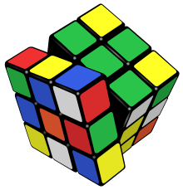**RM:** OK, he’s a strange guy that does weird things, but, anyway, that’s not important. The scene is of two guys sitting on a park bench. One of them is blind – you know he’s blind because he has a cane and is wearing the glasses – next to him is a sighted person, and the blind guy has a Rubik’s cube which he twists and sets it in front of the sighted guy, and says: “Is this it?” And the guy looks at it and says: “No”. So, he takes it back and twists the Rubik’s cube once more and again puts it in front of the guy saying: “Is this it?” and the guy goes: “No”. Now, that’s a literal example of a blind search. There’s no domain expertise being employed to solve that Rubik’s cube problem. Another one is in the great movie *Dumb and Dumber*. By the way, if you go back to the Rubik’s cube there is a chance that the guy might solve it, right?

**JC:** Indeed.

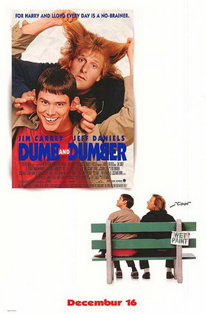**RM:** There is a chance, and that leads us to something called Borel‘s Law, but I’ll talk about that next, but in *Dumb and Dumber* . . .Have you seen the movie *Dumb and Dumber*?

**JC:** I haven’t seen that either, no. I have heard of it though.

**RM:** Oh, Ok, well there’s a great scene where Lloyd Christmas played by – man, the name escapes me for the minute – anyway, he plays a kind of dumb guy who goes up to this good-looking lady and says: “What’s the chance of you and me getting together, is it about one in a hundred?” and she says, “No, it’s about one in a million.” He then says: “Are you telling me there’s a chance?” That was his response.

**JC:** It’s not Jim Carrey, is it, by any chance?

**RM:** Yes, it was. It was Jim Carrey. He said “But you’re telling me there’s a chance.” Now, the reason that is funny, and the reason the Rubik’s cube example is funny, is because we know the chance of that happening is so small that it will never happen. And, the more complex your design is going to be, the more complexity that you want out of your final search programme, the more difficult that problem is going to be, and so domain expertise embedded in the programme is absolutely necessary in order to get you to the end result.

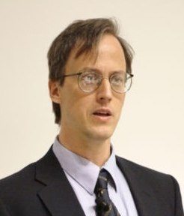**JC:** OK, so coming back to your WD40 example here; presumably, if you had enough trials, you might eventually end up with a WD999099, not that anybody would invest in that because it would be a complete waste of money to try and produce something like that, but I’m thinking that – I mean I’m just throwing this in sideways to see how you react to this – some people might say: “Well, you know, in a universe as big as ours, and perhaps even a multiverse, then maybe that chance just comes up somewhere, and in terms of evolutionary biology, you may in fact get evolution happening, even though it’s extremely unlikely and an anthropic understanding: “Well, we’re just here, we ourselves in this world, and we think we’re special, but actually we’re just thrown up by chance in a multiverse.”

**RM:** Yes. In fact I think William Dembski refers that as probability-of-the-gaps, and it’s an apt description. Let me tell you what we did. We wanted to come up with a probability that would have everyone saying: ‘No, that’s impossible.” And if the probability of something happening is so small that it can’t be comprehended, then we can announce it as being impossible. That’s something referred to, by the way, as Borel’s Law. It actually isn’t a law; it’s more of a rule of thumb, if you will. But, as I type, there is a chance that my thumb will quantum tunnel through the space bar when I hit it; it’s a finite probability. But I can do that forever [and tunnelling will never happen].. So, how do you come up with a probability that is inarguably so small that it can’t be questioned? Ok, here’s what we did: we took a Planck length – now, a Planck length is a small length that we use in String Theory, and to give you an idea of how small it is: if you scale a Planck length up into an inch, the diameter of a proton would be several light years. I mean that is small. So, we divided up the universe into Planck cubes, which is a little cube that has a Planck length on each side, and there are so many Planck cubes in the known universe, then we took the Big Bang cosmology estimation of the age of the universe, and we divided that up into Planck times – now, a Planck time is the time it takes light to travel a Planck length and since Planck lengths are really so very small, it doesn’t take very long for light to travel that length – then, we multiplied the number of Planck cubes in the universe times the number of Planck times since the beginning of the universe, and we got a number, and we said: “Look, if there is one chance in all of this happening, then no, it’s impossible . . .

**JC:**  OK

**RM:** . . . it doesn’t happen.” Then we even said: “Well, maybe we’re not thinking as small a probability as we need to.” So we took the theory out of string theory, which says there’s ten to the hundredth [10100] to ten to the thousand [101000] parallel universes and then we said: “OK, suppose there’s ten to the thousand universes, and we’re going to assume that each universe is like ours, so we take whatever the Planck cube/ Planck time thing is and we’ll multiply it by ten to the thousand, so that way we have all sorts of probability. Now, I don’t think anybody can argue that one chance in that big number is ever going to happen. Yet, we were able to show that in a simple problem of choosing random letters in order to generate meaningful phrases that one could not even – and this is going to sound amazing, and you have to look at the book for the mathematics because the results are mind-blowing, but the mathematics are totally solid – generate a document as long as the Gettysburg Address with that information content. So, yes, there can be a probability, but, you know, it’s like my thumb quantum tunnelling through my space bar, or one chance in all these big numbers - - - - - - -

**JC:**  As you say, I love that phrase: “there’s a chance of the gap”, did you say?

**RM:** Oh, I think Bill Dembski refers to it as the probability-of-the-gaps.

**JC:**  Probability-of-the-gaps, yes.

**RM:** And it’s just like Lloyd Christmas saying in *Dumb and Dumber*: “So, you’re telling me there’s a chance.”

**JC:**  Yeah, yeah. So, blind search then is just a complete waste of time to consider that to be an explanation of what’s going on in the natural world. This is why, of course, we do have these evolutionary algorithms, which purport to show that, in fact, the system itself can generate the information that’s necessary for it not to be just a blind search, but to be a quasi-intelligent search that’s going on in nature. But, you that say these evolutionary algorithms are not really doing that; they are smuggling in information from the programmers in every case. So, how do you actually show that that’s the case?

**RM:** Let’s go back to a 1997 paper in the open literature that introduced something called the No Free Lunch Theorem, and the paper really popularised the idea, although the concept had been presented before, that if one did not have domain expertise, if one didn’t have any idea of where one was going, that one search would be as good as any other search. It was really an astonishing result that took the machine intelligence community by surprise, because before then people would say: “My algorithm is better than your algorithm,” and they’d try to publish and prove that, but the No Free Lunch says that: No, on average, every computer search algorithm is as good as any other one. Now, that being the case, that means that, on average, blind search is going to be as good as any other search that we have, an evolutionary search, so that’s the reason that we can compare any search process to the blind search. Look at the difference between the blind search and the results that were achieved, and we can literally measure the distance between the two, and we can do it in bytes, and that’s something called Active Information, which Bill Dembski and I introduced in an engineering paper back in 2007, or something like that.

**JC:** OK, so when you take these things like Avida, EV and the others that are out there, they seem to fair better than a blind search. How do you go about showing that the reason why they do is because they’ve had active information put into them in some way; whether that’s done deliberately or unintentionally, that’s your claim?

**RM:** Well, I don’t believe that any of the people that write these programmes do this on purpose for the reasons of deceiving. I think that they’re simply numbed by the familiarity that they have with evolution. They say: “Well, yeah, it needs to be there.” In EV, for example, there’s one element in there that tells you you’re getting closer, you’re getting closer, you’re getting closer to the answer that I have designed in my programme for you to achieve. If I were to hide, and here’s an example, an Easter egg in the State of Wyoming and I said go find it by blind search, you would have a big problem finding it, because Wyoming is really big and the Easter egg is really small. But, if you have a kind person with domain expertise telling you you’re getting warmer, you’re getting warmer, or, no, you’re getting colder and now warmer again, that person with his domain expertise would guide you towards the egg, and you would find it in a finite amount of time. Without that expertise, you couldn’t do that. In EV, for example, it has a literal thing called a Hamming Oracle that tells you each iteration how close you are to the solution, and therefore guides you towards that solution. It’s just like the guy in Wyoming telling you where to find the Easter egg. Not only can we measure it, we do have the ability to identify the source of that active information, and the expertise that is placed within the algorithm.

**JC:** So, when you point that out, what’s the response of EV theorists? Do they come back to you and say: “Well this particular component of the programme which has put in the active information corresponds to this aspect of Neo-Darwinian theory.” Do they come back to you?

**RM:** Well, they do, because some people say: “Well, that’s just the way nature is.” Ok, well, if that’s the way nature is, then nature is supplying information to guide the evolutionary process. So, fine, I would agree with them. We have found, in general, that the writers of these programmes are strangely silent to our criticism, and usually that isn’t the case. When you write something that even smells of Intelligent Design, you get all these new atheists coming out and really trolling you. No, that doesn’t happen. The bigger problem is that the results have not been popularised, and therefore people are doing this again and again and again, and we have written a number of papers where we actually go to a popularised evolutionary programme and say: “Ah, not only does it have this active information, but here’s the source of it.” And then another paper comes out, and we say here’s the active information, here’s the source of it. So the problem is it’s repeated and, I think, that as people find out that it’s going to impress them and tell them, I think we’ll see another bunch of wasted papers.

**JC:**  What confuses me about this is when they do come back to you, or they might come back to you, what part of Neo-Darwinian evolution could they point to as a source of this active information?

**RM:** That’s a good question. I don’t’ think that they have a solution. They can say that’s the way it is. You mentioned the anthropic principle, I think that they say that this is the biological equivalent to the cosmological anthropic principle, and, you know, gosh, if this wasn’t the way it is, we wouldn’t be here to know to write some papers about it, so I think that’s a kind of response also.

**JC:**  A kind of circular reasoning – it does smack of that, anyway. I mean one of these things that you mentioned was the NASA antenna. This has been produced by evolutionary processes, but you say there there’s also example of active information?

**RM:** Oh yes, yes. Well, here’s the thing: engineers design things; that’s the reason, I think, that most engineers are more friendly towards Intelligent Design than other people, because we know what goes into design. But, for the evolutionary development of the antenna, they needed domain expertise, and what they did was to bring in this software that analyses the response and the characteristics of the antenna that they were trying to synthesise, and so it’s just like you’re getting warmer, you’re getting warmer, you’re getting colder, you’re getting colder every time a new design potential is presented by the computer to this software. It says: “Ah, this is getting better, you’re getting warmer, you’re getting closer to the solution.” And so, basically, the computer allows us to explore numerous solutions to a design problem. And the computer lets us walk through those very, very quickly. One of the ways to walk through them very, very quickly is using evolutionary programming, and that’s what they did. But, the domain expertise was: (1) the use of that [domain smart] software, and (2) the knowledge on how to guide the design of the antenna using this software.

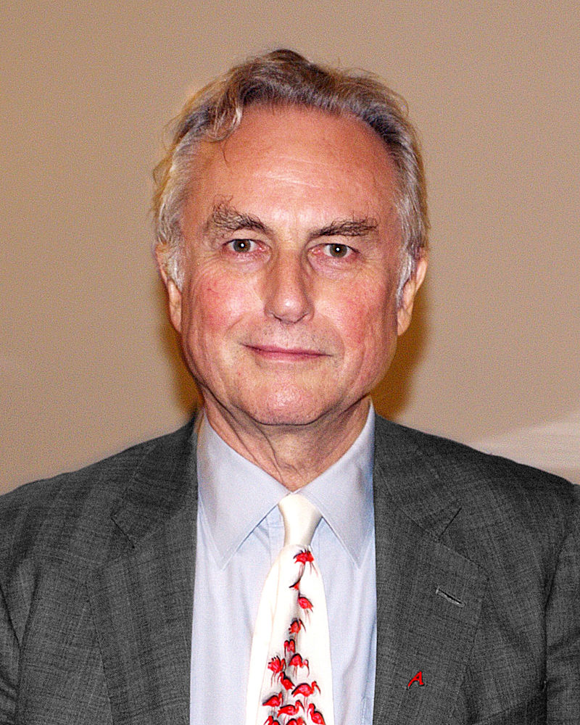 **JC:** And you also discuss a little bit Richard Dawkins in your book and his step-by-step approach that he talks about in his various books, and I was very interested that you did that, because having read a couple of books by him in previous years, I was struck by a kind of suspicious thing that he’s doing there sometimes. I mean, I remember *The Blind Watchmaker* and he had these computer creatures that he’d created on his computer that he said could evolve step-by-step into new creatures by random changes plus selection etc., and they were gradually following an evolutionary pathway to a creature at the end of the process, and I did think well that works on your computer, but how does that actually map onto reality? Why should I think that any of those creatures would be viable creatures in the real world? You know, aren’t you just assuming the truth that there are these viable pathways that you’re describing, because you already believe in gradualism, you already believe in step-by-step processing. You seem to be offering a criticism a little bit like that in your book.

**RM:** Well, yes, I think the most popular Dawkins thing is the phrase: “Me thinks it is like a weasel”, which he took from Hamlet, and what Dawkins did, if that’s what you’re referring to, was to apply a little evolutionary programme where he applied the three steps of classic evolution: mutation, repopulation, survival of the fittest - repeat, and he kept on doing that. But, you will notice that in that process that every time, in determining the survival of the fittest, he was able to ascertain how close he was to his target. In other words, he had a goal in mind. Another thing Neo-Darwinian people say is that you don’t have a goal in mind. Well, as it turns out, all the algorithms published by the Neo-Darwinians have a goal in mind. But, Dawkins had a goal in mind too, and what he was doing at every step by determining the fitness was saying: “Ooh, this one’s really close; this one is far away; this one is close too”, and so he was doing exactly the same thing as the Easter-egg hunt in Wyoming.

**JC:**  It doesn’t really prove anything, does it, because it doesn’t mean there’s necessarily going to be a viable organism in the real world that will correspond to that stage in the process?

**RM:** Ah yes. Well, that’s another thing, which, I think, a lot of the people who write these programmes ignore, and that is that at every step you have to have functional viability. For example, every step in Dawkins’s simulation is not a meaningful phrase in the English language. It would die in the evolutionary sort of development, so there has to be functional viability at every single point in the evolutionary process, and we talk about that in the book a little bit also.

**JC:**  Fascinating stuff. Now, I want to ask you about this notion of the Conservation of Information, which you suggest places a limit upon what these evolutionary programmes can do and are likely ever to do. Could you give us an idea of what that means – the Conservation of Information?

**RM:** Well, there are actually a number of aspects to Conservation of Information. One goes back to the No Free Lunch Theorem saying that all search algorithms, on average, are going to perform the same, and so, therefore, we can always go back and compare things to a blind search. It turns out that all the evolutionary programmes reach something I call Basener’s Ceiling, above and beyond which that evolutionary programme cannot go. You cannot exceed the expertise of the resident oracle or source of knowledge. So, for example, if I generate a computer programme that is going to learn how to play chess, which has been done, that programme is not going to go on and learn Go; it’s not going to give financial advice; it’s not going to do anything above and beyond what it is designed to do. It’s a process that hits a ceiling. And nobody has ever come up with a viable reason or a viable algorithm to actually exceed that ceiling. There are some that say: “Well, you can evolve to a certain point, then you change the fitness, and you go to another point, and then you change the fitness and you go to a third point,” but the scheduling of those changes in fitness makes the problem much more difficult and much more unlikely to occur by chance. Those are the two basic ideas.

**JC:**  Well, that brings us onto this rather difficult notion of the Search-for-the Search, but I do want to ask you just briefly to give us an idea about this, because you’re saying that the algorithm might have to be tweaked here and tweaked there in order to accommodate the next stage of evolution, or whatever then, it seems that in a way we’re looking for more and more information to be input in order to make this series, or instantiations, of the computer programme to work, but you say in the book that searching for these ‘searches’ is expensive in terms of information, and in fact can be even far more expensive in terms of information, so if you’re searching for the perfect search that’s a terrible situation to be in. Do you want to say something about that?

**RM:** Yeah, it is a terrible situation. Most computer scientists that do search algorithms have their own favourite catalogue of searches. If you look at the number of search algorithms, they are enormous. You have – let me see if I can rattle some off – you have particle swarm, you have steepest descent, you have evolutionary search, you have something called taboo search. There’s a list of them in the book. I think we list like eighty different possible searches, and the question you come up is which one of those searches are you going to use? The best you can do is, again, go to your domain expertise and say you know for this sort of problem this sort of search algorithm works very, very well. But suppose, on the other hand, that we were able to give the computer the job of searching for the search, and so what we want to do is to look through all those different search algorithms and choose the best one for the problem that we have. It turns out that that searching-for-the-search is exponentially more difficult than the original search, so you can’t kick the can down the street. As you search for the search, (and I guess you could search for the search for the search – we’ve never thought about that) there’s a regress exponentially more difficult.

**JC:** So it doesn’t matter where you go with analysing the situation, you keep coming back to intelligent input, and if you don’t have intelligent input, you’re just presented with a bigger and bigger problem to do it in a blind way.

**RM:** Yes, exactly, yes. Imagine doing a blind search for an algorithm which has a certain amount of active information. That makes the blind guy sitting next to the sighted guy with a Rubik’s cube look like a genius, because that is going to take forever squared.

**JC:**  And some kind of perhaps Neo-Darwinian search for a perfect Neo-Darwinian theory? That’s unimaginable.

**RM:** It is, it is unimaginable, absolutely. I was writing a computer programme, and one of my colleagues here, Randall Jean, came in and asked me what I was doing. I told him I was writing an evolutionary programme and he says: “Oh, great, when can I talk to it?” His response really humorously illustrates the Basener’s Ceiling idea. That evolutionary programme was going to do exactly what I wanted it to do, and it would do no more. That is also true of all the programmes that have been generated by the Neo-Darwinists to purport illustration of Neo-Darwinism.

**JC:**  OK, well let me throw at you a couple of challenges here. So, some might say you’ve got a false dilemma: Neo-Darwinian processes are not working here, so you’re saying: “Ah, well it’s intelligent design.” Is there not a third way? Some are pointing in the direction of a kind of Neo-Lamarckism and saying: “Well, what about the possibility of epigenetic processes that might be helping to drive evolution, so there may be these stable traits that are inheritable that can’t be explained by DNA changes, they’re sort of extra to DNA sequence changes, they’re epigenetic processes. Maybe these can be used to explain evolution. Is there anything to that, do you think?

**RM:** Well, the question is where does that information come from eventually? Is that something which has been generated by chance, or whatever? I have been following the work of James Shapiro at the University of Chicago, who is not a proponent of Intelligent Design, but his work on epigenetics is, in my mind, just jaw-dropping. Again, I’m not a biologist, but I know enough to be dangerous. Shapiro’s exposition says that yes, in the cell there’s a teleological purpose for the cell. In fact, cells will do things which aren’t used for a few generations down the road, and that there is this idea of ‘targeting’ in the process. These things in epigenetics are just mind-numbing. And, again, if you have this epigenetic thing working, you have to ask where does that information come from? What is happening here? Why does it happen? It’s kind of the verb, if you will, and the noun of DNA. So, you have all these processes, which are happening – and man! Getting the process to happen, that’s a rough design problem in itself.

**JC:** So, that wouldn’t get rid of the information problem; it would just demand an explanation and it would be subject to the same kind of analysis?

**RM:** Yes, exactly, that’s my understanding, and in fact I think Shapiro uses the term Genetic Engineering which happens in the cell, and they’ve had to develop an algorithm, a procedure, to do these things.

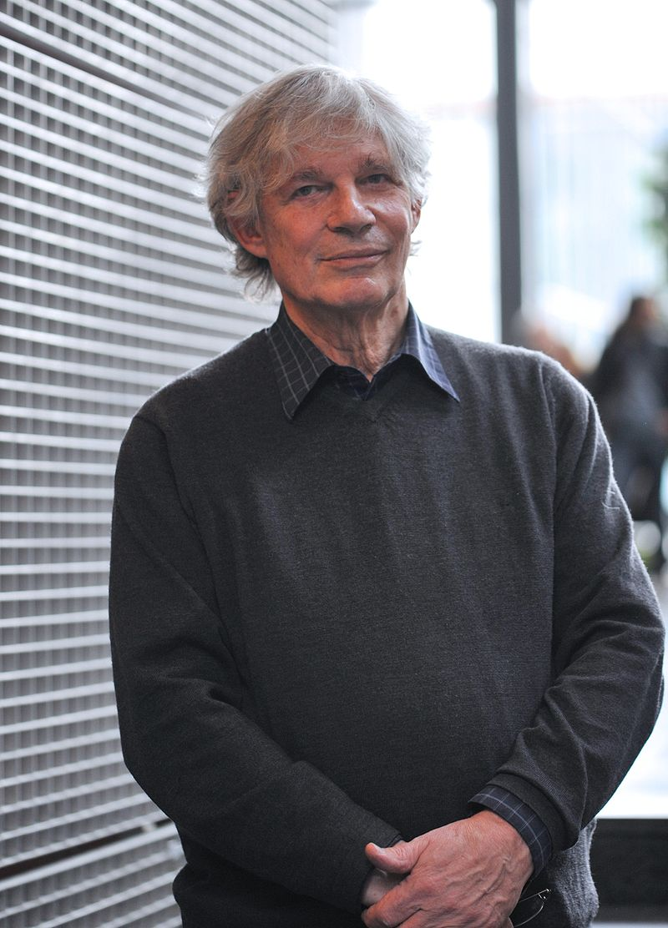 **JC:**  Something to watch, certainly. Ok, what about the other one then which I’m calling the sort of [Stuart] Kauffmann approach. So, this would be more the idea that there are self-organising principles taking place within biology in addition to Darwinian natural selection, so maybe these self-organising ideas can help to provide the active information that’s necessary?

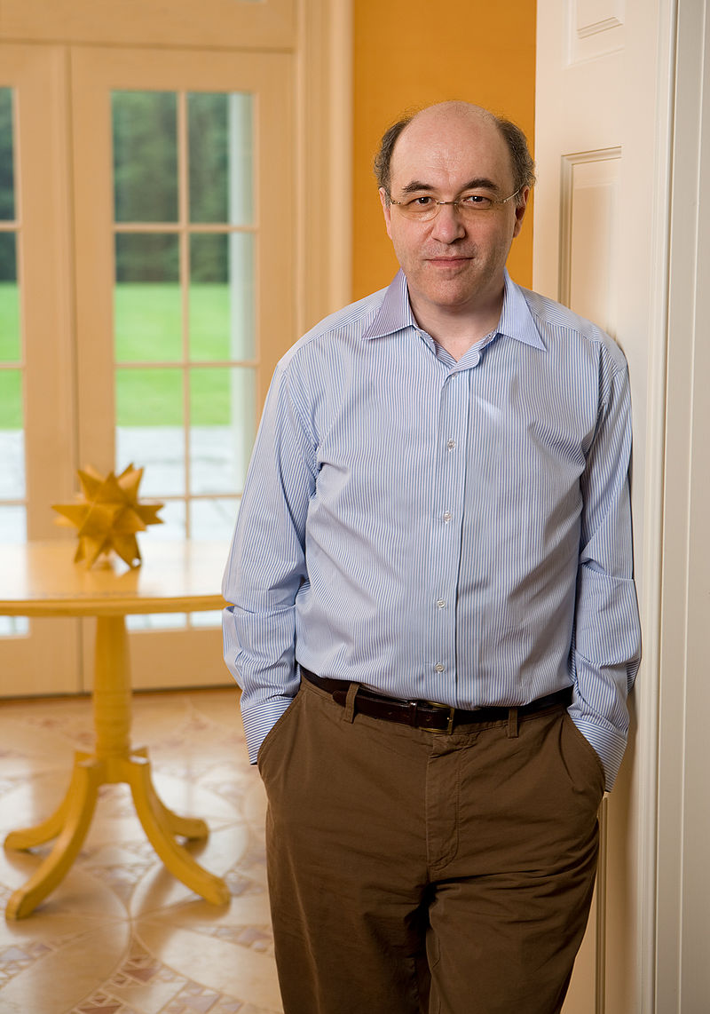 **RM:** Well, I am somewhat familiar with Kauffmann’s work, and I don’t know whether you’re familiar with Stephen Wolfram and his book *A New Type of Science*, where he explores some of the same sort of things? But, Kauffman has been a big proponent of artificial life where he looks at finite-automata and interacting rules. I’ve talked about this with my colleague Keith Schubert here – I mentioned he does work in extreme environments where there are life forms that exist in sulphur caves – and he’s using these approaches to attempt to model the life that exists there, and his comment is that these sort of things happening are basically probability-of-the-gaps sort of arguments again. That yes, you can get these sort of things, but show me. I maintain there exists no hard-science model of Neo-Darwinian evolution. If that’s wrong, and Kauffmann is right, I would like to see it. I think Kauffman actually admits to the fact that there needs to be a guiding force behind even his work.

**JC:**  Right.

**RM:** I don’t remember where I read that, but Kauffmann has a chapter in a book that I edited with Michael Behe and William Dembski – he’s very critical of Intelligent Design of course – but I think he’s honest in his critique of the limitations of the procedure he’s using.

**JC:** So, if Kauffmann’s right, that wouldn’t be Neo-Darwinianism properly, anyway, would it?

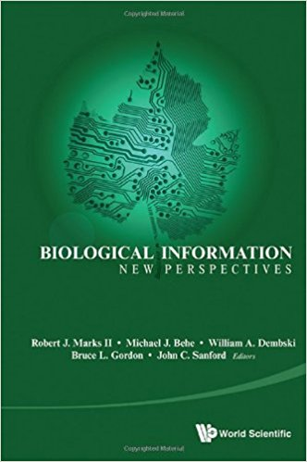

**RM:** Well, you have to ask what guides the sifting property. It does turn out that in any search, in any process, where you develop the specification, there’s always randomness. You have randomness in evolution, for example, evolution has mutation – that’s a stochastic phenomenon – and there are ways of applying probability in these search algorithms to shake yourself out a local minima to get better and better and better, but still you have to have an idea and you have to have a guidance in the sifting property to arrive at your final result. There has to be a guiding force, and that is something that seems to be common to everything in evolution, as I understand it from biology; certainly from an engineering/computer science point of view there needs to be something guiding the process. So, if Kauffmann is right, there still needs to be guidance there.

**JC:**  Yes, that would still need explanation, absolutely. Ok, well before we move to the last section, which is to do with Artificial Intelligence, which is related to what we’ve been talking about, I do want to ask you a couple of questions to do with the other book I read just before yours, another excellent book: *Being as Communion, a Metaphysics of Information* by your colleague William A. Dembski, and there are a couple of very interesting – well, many interesting – thoughts, but these are the ones I want to ask you about.

The idea that information may be fundamental, that is, as far as I understand it correctly, in the final analysis when we’re investigating the ‘stuff of nature’, we never really arrive at a fundamental knowledge of what matter is. Instead of that, we’re presented with layers and layers of patterns and relationships, which may be described in informational terms, so, therefore, may be reality is fundamentally information. What do you think of that idea?

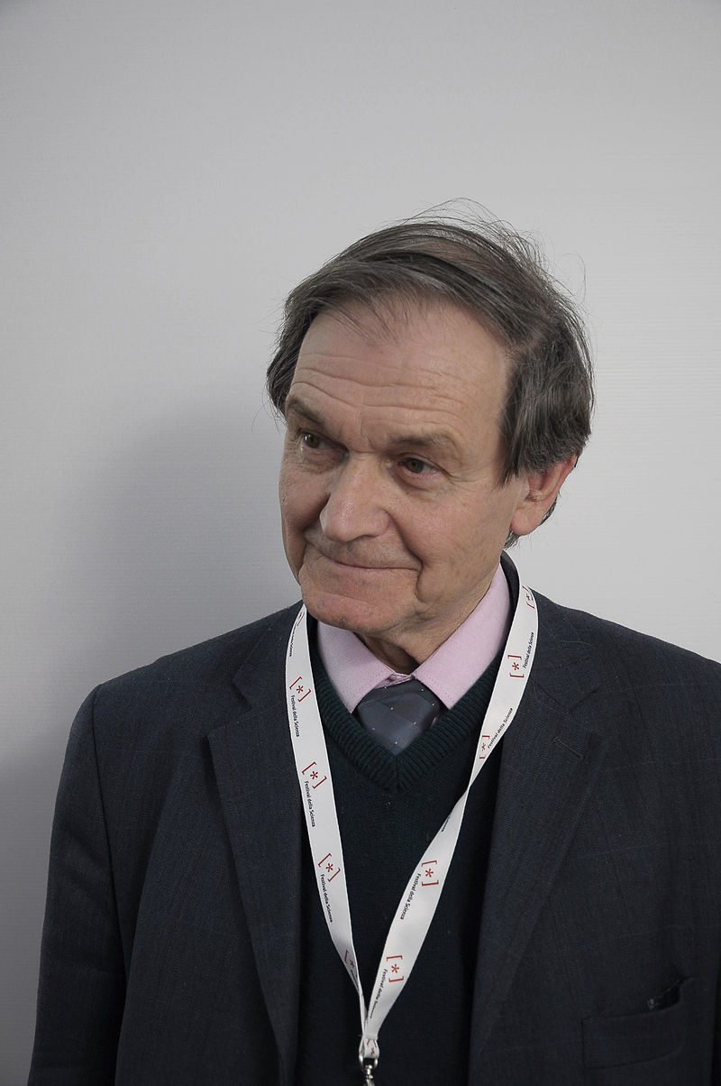 **RM:** Well, Roger Penrose recently had a comment that reality is, he thinks, in some ways strangely related to consciousness, and that this reality doesn’t come out until there is an observer, because it always takes an observer to collapse wave functions. So that’s something I’m very interested in, and am going to read up on consciousness being a part of reality. I do agree with Bill (Dembski) that information is foundational to our universe. I gave you the example of the Komogorov or KCS sort of information about the 3-dimensional printer that printed out the bust of Churchill and the bowling ball. That in itself is a way, which I think can be universally applied to measure the complexity of everything in the universe. You measure it by the programme that generates it, and if there’s a programme that generates it, there’s a shortest programme that generates it, and the shortest programme is something known as the object’s Komogorov Information Content. Chaitin calls them elegant programmes. There is a shortest programme to generate the bowling ball, There exists the shortest programme to generate the bust of Churchill. That describes the complexity of the object. Then, you have to fold in some of the ideas of ‘meaning’ into the object and ‘meaning’ must come from context, and that’s something that Winston Ewert has pioneered. He has actually come up with a way to measure meaning of objects, and that meaning can actually be measured in bytes. The results are really incredible. For example, and this is in the book also, getting a Royal Flush using a deck of cards in a game of poker has a lot of meaning. We can actually measure the meaning associated with the Royal Flush in the context of poker and measure it in bytes.

It also answers the question of complex things existing all the time. We apply Winston [Ewert’]’s theory to one snowflake, and there’s nothing remarkable about it. Snowflakes are very complex, but they don’t have a lot of meaning. Even looking at two different snowflakes doesn’t have a lot of meaning either, but if you apply this theory to two identical snow flakes, all of a sudden the meaning, the algorithmic specified complexity, goes up. So, this is a theory that is developing. I actually have a student here that’s looking into some other aspects of algorithmic information theory and its applicability possibly to data mining, and it’s just a fascinating area.

**JC:**  Yes, indeed, and I was fascinated by what you were saying about somebody theorising about the collapsing of the wave function with respect to reality itself, and the consciousness being involved in this, and I was thinking what William Dembski at least seems to be moving towards in that book is the notion that the universe might actually be mind-like, and I don’t think he means in a pantheistic sense, but more like the product of mind, a thought perhaps, maybe thought – a really interesting thing to explore. Do you have anything to say about that kind of thinking?

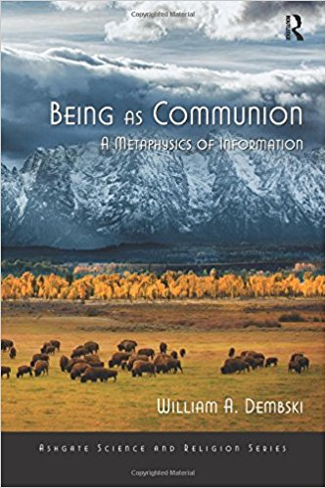**RM:** Well, it’s simply, as I understand it, that the outcome of an observation doesn’t happen until the observation happens; that’s the collapse of the wave function. There’s a fantastic theorem called Bell’s Theorem. I always used to wonder about this with pre-destination versus free will. My father explained it to me with a question: “If you have a hole and you dig a ditch, is the ditch there and you just took the dirt out, or are you creating the ditch?” That was his simple explanation, and it really captures the idea of the [free will versus predestination]. And frankly it doesn’t matter. But there’s been work done for when a wave equation collapses. Has the reality existed there before you looked at it, and you’re just removing a cover from that reality, or did you actually create something random? It seems like that ditch sort of analogy, but as it turns out, it isn’t. Bell’s Theorem came along and gave an experiment, which has been done without loopholes in the past few years to show that: No, what is created is random; it didn’t exist there before. So, it’s a creation of a few bytes of information, if you will. This happens all the time, and every time we observe something and these wave functions collapse, we have new information on the universe; it’s just astonishing.

**JC:**  And perhaps this is pointing in the direction of the Mind (with a Capital ‘M’) or God, we would say from a Christian perspective, actually collapsing as it were the massive wave function, which is the reality in which we live. It’s certainly an interesting thing to think about, isn’t it?

**RM:** Well, I think one of the interesting question, which my colleague Keith Schubert, a really great Christian, pointed out: who was the first observer? Who is the first observer that started reality from ex nihilo? I don’t know how relevant it is, but it sure is fun to think about.

**JC:**  Yeah, absolutely, and of course your example there with the dig-in-the-hole reminded me of Winnie the Pooh and Piglet moving a hole from one place to another having dug it. Lastly, just briefly, about this Artificial Intelligence question is another issue discussed in the book: you say that Artificial Intelligence will never, in your view, match the creativity of the human mind, it will never be truly conscious, and this is very interesting because we are frequently being warned to be fearful of artificial intelligence, not so much how it might be used by human beings, but precisely because of the possibility of its own self-awareness and creative intelligence. You challenge that in the book. Tell us why you basically do challenge that?

**RM:** Well, again, this is going back to fundamentals. It turns out that the Turing machine can only do algorithms; it can only perform recipes. A recipe is an algorithm like when you bake a cake, it tells you what to do; when; how many eggs to add; how to whip it up; how long to put it in the oven, so it’s a sequence of steps, And that’s exactly what an algorithm is. Now, the original Turing machine could only do algorithms. It turns out that what can be done on every computer today can also be done on Turing’s original machine. It might take 500 times as long, but it can still be done on Turing’s machine. The takeaway is that computers can only do things algorithmically. We have a number of examples of things that are non-algorithmic. From the nerds’ perspective, the so-called 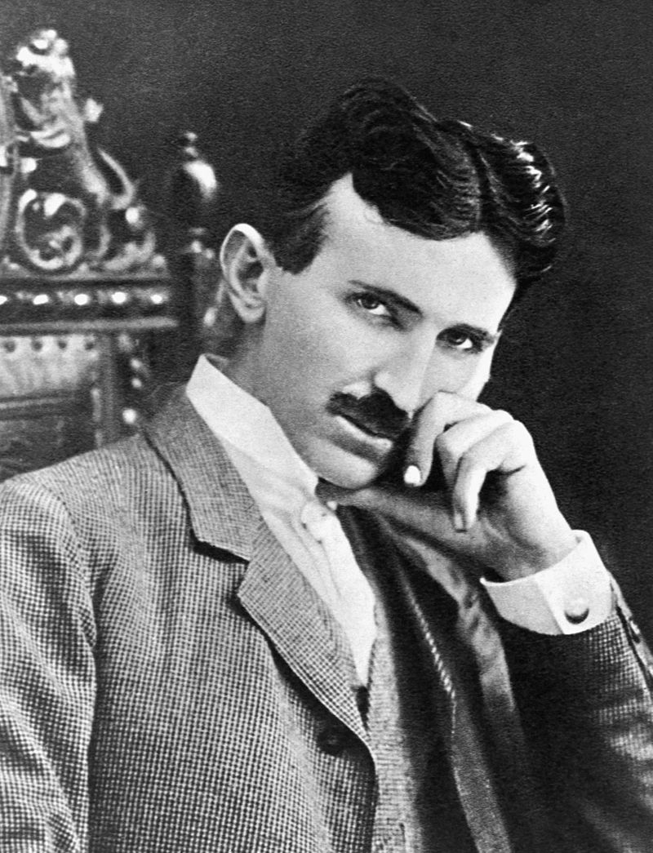Turing Halting Problem, which I won’t go into, but there are many solid examples. Some more interesting examples, purported by Rodger Penrose, have to do with the creativity we see in human beings. Remember I said that an evolutionary computer programming that was supposed to learn chess would never go on to give you financial advice. It does what it was programmed to do, and so it stops there. And there are numerous examples, both in science and in the arts of this so-called ‘flash of genius’ [above Basener’s ceiling]. Friedrich Gauss, who was a big mathematician, said that he got an idea like a sudden flash of lightning and the riddle was solved. Nikola Tesla said the idea for the alternating current machine just came to him out of nowhere, and he was able to sit down and famously write his diagram of the machine in the dirt. And even in the arts, this is going to sound funny going 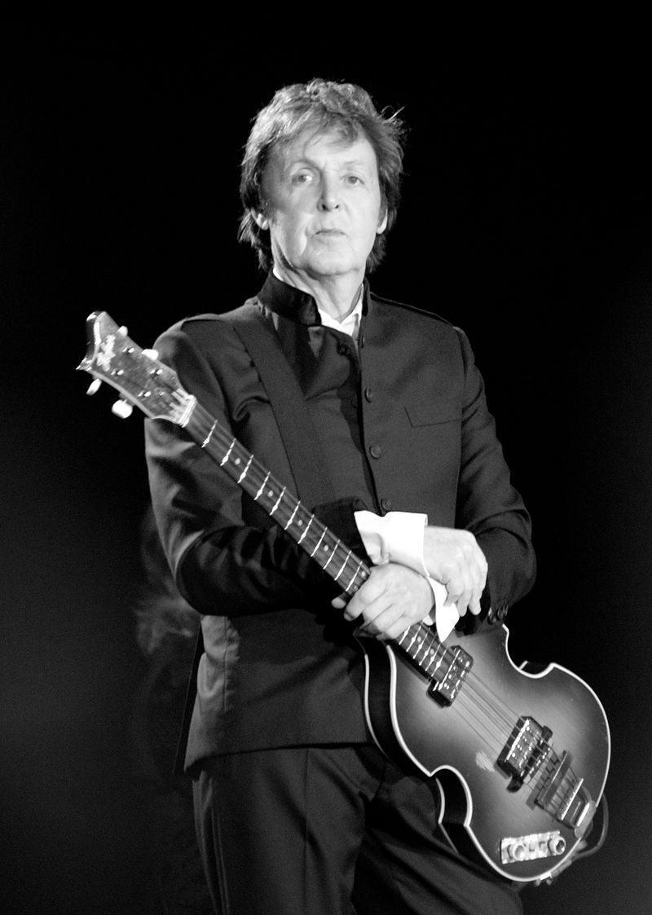from Nikola Tesla to the Beatles, but Paul McCartney said he woke up one morning and had this tune running through his head, and he thought: “I couldn’t have written this. Where did this come from?” and it was the tune for *Yesterday*. It had come to him in a creative flash. In the United States it used to be the law that you had to have had a flash of genius before you received a patent. They’ve removed that terminology, but it is this creativity, and the implications of this are more than just the mind not being a computer. But I think that if one were to take these non-materialistic ideas that they would have application all over the place, and that’s something that we’re exploring right now with one of my students.

**JC:** Sure, I just have one comeback on that: Ok, so Paul McCartney says he woke up and had this idea. You’re saying that’s a flash of inspiration, but couldn’t you argue that, in fact, his brain was working various algorithms while he was asleep, and whilst he wasn’t conscious of it, up came the idea, but it was robotically created while he was asleep.

**RM:** Well, I will tell you that so far there has been no computer programme that has ever generated anything creative. They do exactly what you tell them to do. Now, some of this deep-learning stuff has come up with some interesting things about composing music or composing plays. The plays are terrible. Have you seen them?

**JC:** No, but I heard an example only a couple of weeks ago on the radio where there was supposedly this piece of music that was composed by Artificial Intelligence. There was a great big headline about it on how wonderful it was, and I listened to it, and as I was listening to it, I thought it was well-crafted, but actually it’s exactly the kind of thing I would expect an early 21st century classical music composer to have written, and I thought to myself they’ve programmed it to do that.

**RM:** Exactly, exactly, and that’s also the case with these plays that they’ve come up with. There’s one on YouTube where they’re acting out this play that was supposedly written by a computer, but you go to the transcript, the script for the play, and it’s embarrassing. It says: the guy’s head was in the clouds, he was at the window, he takes the shotgun off the wall and puts it in his mouth. All totally disjointed phrases, but if you watch the play, the actors make it look so smooth that it looks as though it might have something to it. But no, I would challenge anybody that said that they have computers that generated something creative. If they do, and can prove it, that’s fine. I believe that creativity, getting back to the fundamentals, is non-algorithmic. You cannot write a step-by-step procedure to do creativity, and computers are limited to algorithms.

**JC:**  Right, so you’re saying it’s in principle impossible, not that the computing capability is just not that advanced yet?

**RM:** No, because, again, there’s something called the Church-Turing Thesis which says that everything we can do on any of the computers we have today can be done on this original Turing machine done in the 1930s on the back of an envelope by Alan Turing. And so they’re all equivalent, and so if Turing’s machine couldn’t do it, none of the computers we have today is going to do it. By making it faster or increasing the memory and so forth, we’re going to get more interesting results, clearly, but we’re still not going to get creativity.

**JC:**  Fascinating indeed. But this does not necessarily mean that we should have no concerns about Artificial Intelligence, because, of course, at the end of the day it is still the case we can ask: “Well, who’s in charge?” In Artificial Intelligence you have the human thing to worry about there, don’t you?

**RM:** Well, you do, and I think that this is probably true of any new technology. For example, take Tesla and Edison. Edison tried to tell everybody that Tesla’s AC [alternating current electricity] was terrible, so he ran around scaring people by electrocuting animals at state fairs. He even electrocuted an elephant with AC. [Tesla worked with Westinghouse.] Edison suggested to the Government that rather than calling the death penalty the electric chair (in France it was called the Guillotine after Dr. Guillotine who invented it), that it be called being “Westinghoused”. So you wouldn’t be electrocuted, you’d be “Westinghoused”. So, there was fear about AC electricity and yet, you know, there are problems with AC electricity. But the advantages are really nice. With computers, we have the same sort of thing: we have loss of privacy; hacking problems; we’ve got malicious attacks, especially the few that we’ve heard about recently, but then there are the positives. My goodness, we have all the world’s knowledge at our fingertips – it just blows my mind. So, anyway, it’s like with any new technology, there’s going to be good and bad, but the idea that a computer will be conscious, that it will understand people or understand things, is just not going to happen.

**JC:**  Really, really interesting – mind-blowing stuff, mind-bending stuff, but it has been a wonderful interview. Thanks ever so much for joining me. It’s not easy, not an easy subject, but I do think it’s well worth engaging with, and I do recommend the book *Introduction to Evolutionary Informatics* by Marks, Dembski and Ewart, which is published by World Scientific, and is available, of course, from other booksellers, including Amazon. Please don’t be put off by it, even if you’re not all that keen on mathematical symbols and the like, because there are still ample discussions, as I said before, plenty of illustrations so that you get the flow of the argument, and it’s even very entertaining in many ways with sections describing how to get the perfect pancake, which I was going to ask you about but it didn’t happen in the conversation. Let me also recommend what I’m calling the companion book to this: William Dembski’s *Being as Communion*, more philosophical, but very much drawing on the kind of research discussed today, also fascinating theologically and philosophically, and I will have links to that book as well in the show notes. So, two books there for your library, both recommended. Just before we close, Dr. Marks, if people would like to find out further information about this work beyond the book, is it the Centre for Evolutionary Informatics that people go to?

**RM:** Yes, The Centre of Evolutionary Informatics is non-profit which is used to support people doing research in the sort of the things we’ve been talking about now, but the place to go for information is evoinfo.org. My wife doesn’t like it because she says it sounds like evil – evil info – but it isn’t evil. Now, there, if you want to make a donation, there’s a place to donate but I think, more importantly, if you want to dig deep, if you’re a true nerd and you want to go into the papers, all the papers are posted there, and you can download them and look at them in a pdf format. What we try to do in the book is to gather all these papers and present the in a fashion where the non-nerd can understand them. Hopefully, we’ve done that in *Introduction to Evolutionary Informatics*.

**JC:**  Wonderful, and you have a FAQs there on that website, but if people do want to ask you any further questions, is that possible in any way?

**RM:** Oh yes, absolutely. Probably the easiest way to get to me is [r.marks@ieee.org](mailto:r.marks@ieee.org).

**JC:** And would you be happy for me to place that on the show notes.

**RM:** I’d be honoured, yes.

**JC:**  Wonderful. Well, it’s been wonderful to speak to you Dr. Marks, indeed a nerd of your calibre, an absolutely fantastic conversation. Thank you very much indeed for coming on the show.

**RM:** Ok, Julian, thank you very much. It was really an honour, and it was a lot of fun for me too.

**JC:**  And that book, *Introduction to Evolutionary Informatics,* is available, as I say, from World Scientific Publishers, as well as Amazon of course, but If you go to worldscientific.com and search for the book there, you’ll find three free pdfs of the preface, contents pages and Chapter 1, which has the introduction to the book, and the index at the back so you can get an idea of how the book reads. And, as I mentioned in the conversation, you can find out more about William Dembski’s book *Being as Communion* by visiting, funnily enough, beingascommunion.com where there’s an ‘about’ page on the book and a series of helpful videos in which Dr. Dembski explains some of the themes of the book, and, actually, just to give you a flavour of that, here he is introducing the thesis of that book.

**Dr. William Dembski** The thesis of my book *Being as Communion* is that the fundamental stuff of the world is information, that things are real because they exchange information, one with another. The subtitle is *A Metaphysics of Information*, and so what I’m trying to do in this book is develop the idea that information is the primary stuff of the world, and I think this really comes smack into the materialistic worldview which is what people face largely these days which is that matter is the fundamental stuff of the world, and that everything needs to be built out of matter. Now, this proposal that information is the fundamental stuff has been out there, I mean people have explored that, and some people have run with it and continue to think there’s something there, but developing this in a way that’s cogent, that makes sense, I think that’s the challenge.

**JC:**  And to hear the rest of that, you’ll have to navigate over to beingascommunion.com

Photo Credits

* Ben Stein photo: <https://upload.wikimedia.org/wikipedia/en/1/10/Expelled_logo.jpg>
* Bob’s Wife Monika & the Stupid horse with granddaughter Melodie
* The Terminator:

<https://en.wikipedia.org/wiki/The_Terminator#/media/File:Terminator1984movieposter.jpg>

* The Pasteur Poster courtesy of <http://christiancalculus.com/index-.html#Pasteur>
* The Imitation Game:

<https://en.wikipedia.org/wiki/The_Imitation_Game#/media/File:The_Imitation_Game_poster.jpg>

* NASA Antenna Picture: Public Domain,

<https://commons.wikimedia.org/w/index.php?curid=671157>

* Norbert Wiener by Konrad Jacobs - http://owpdb.mfo.de/detail?photo_id=4520, CC BY-SA 2.0 de, <https://commons.wikimedia.org/w/index.php?curid=6090164>
* WD-40 <https://en.wikipedia.org/wiki/WD-40>
* Weird Al By Antmantrunks - Own work, CC BY-SA 3.0, <https://commons.wikimedia.org/w/index.php?curid=9734038>
* Rubik’s Cube. Wikipedia.

<https://en.wikipedia.org/wiki/Rubik%27s_Cube#/media/File:Rubik%27s_cube.svg>

* Dumb & Dumber. By Source, Fair use, <https://en.wikipedia.org/w/index.php?curid=17213577>
* William Dembski By Kenosis at English Wikipedia, CC BY 2.5,

<https://commons.wikimedia.org/w/index.php?curid=10532436>

* Easter Eggs. By Ikonact - Own work, CC BY-SA 3.0,

<https://commons.wikimedia.org/w/index.php?curid=1905684>

Richard Dawkins By David Shankbone - Own work, CC BY 3.0,

<https://commons.wikimedia.org/w/index.php?curid=11639311>

* Stuart Kaufmann By Teemu Rajala - Own work, CC BY 3.0, <https://commons.wikimedia.org/w/index.php?curid=10745820>
* Stephen Wolfram's PR team/Stephen Faust - Received via email from Stephen Wolfram's staff, CC BY-SA 3.0, <https://commons.wikimedia.org/w/index.php?curid=8328086>
* Roger Penrose By Cirone-Musi, Festival della Scienza, CC BY-SA 2.0,

<https://commons.wikimedia.org/w/index.php?curid=19318743>

* Royal Flush By Photo: Graeme Main/MOD, OGL, <https://commons.wikimedia.org/w/index.php?curid=26889555>
* Tesla By Unknown - Downloaded from: <https://historyrat.wordpress.com/2013/01/13/lighting-the-1893-worlds-fair-the-race-to-light-the-world/>

Public Domain, <https://commons.wikimedia.org/w/index.php?curid=3139472>

* Paul McCartney By Oli Gill - originally posted to Flickr as Paul McCartney, CC BY-SA 2.0,

<https://commons.wikimedia.org/w/index.php?curid=11790856>

1. <https://thebestschools.org/features/50-influential-scientists-world-today/>